Name: _______________________ ID: _______________________

**Analytical Chemistry II – Quiz (8th March, 2022)**

1) How does $v_{o}$ relate to $i_{i}$ in this circuit? Write down the formula.

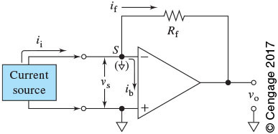

2) What are the sources of chemical noise in analytical measurements? List three sources.

* undetected variations of temperature and pressure affecting chemical equilibria
* fluctuations in humidity affecting moisture content of samples
* laboratory fumes that interact with samples/reagents